Heuristic Analysis of Dassault Systèmes Website

The analysis is done by asking some questions based on the user perspective. This helps us to find the issues within the website. There is an answer for the each question along with the justification.

Questions:

1. Is the user aware of the status of what is happening (navigation) in the website?

Result: **PASS**

Reason: The breadcrumb showed on the page allows the user to understand the navigation of where he is exactly and doing what.

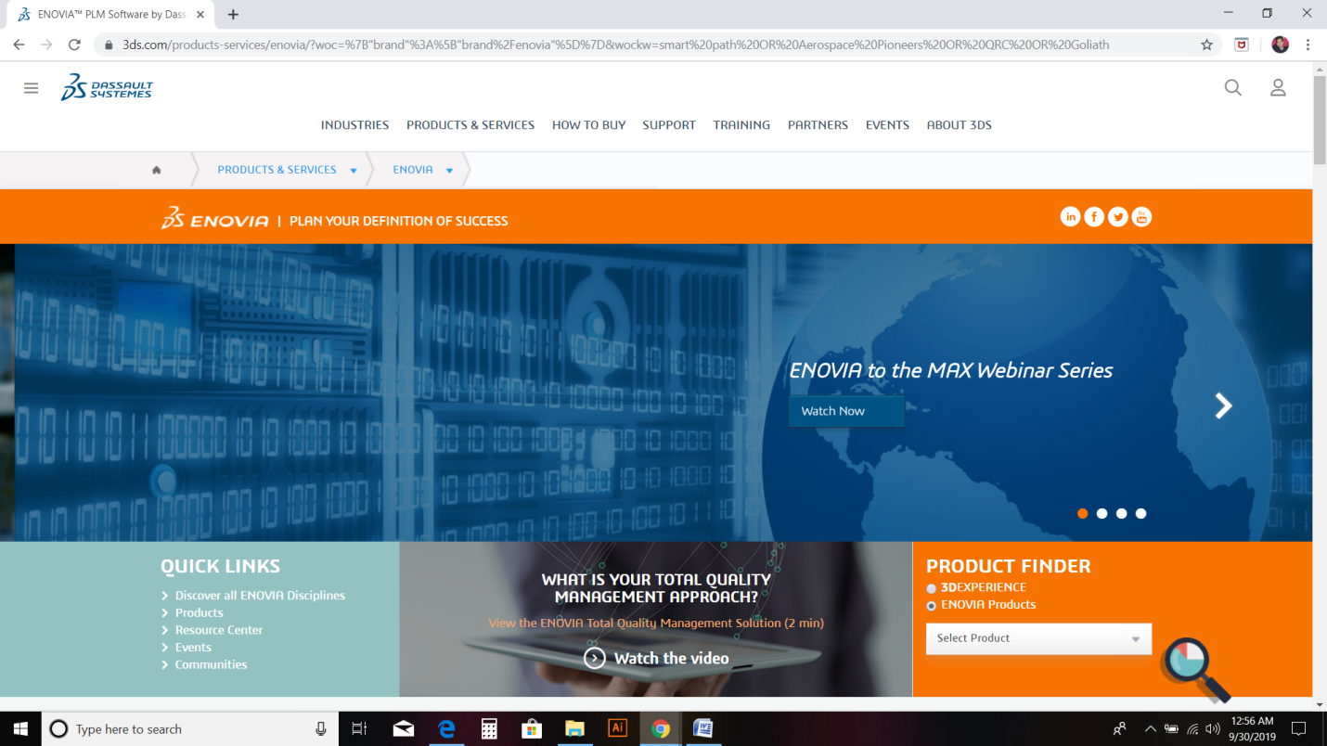

1. Are the terms used in the website are familiar to the user, rather than system oriented?

Result: **FAIL**

Reason: There are some technical terms used in the website. However, we cannot say that it is completely a failure, because the website of a mechanical software company. Therefore, it is obvious that there might be some technical terms used in the website. However, it is recommended to use less technical terms.

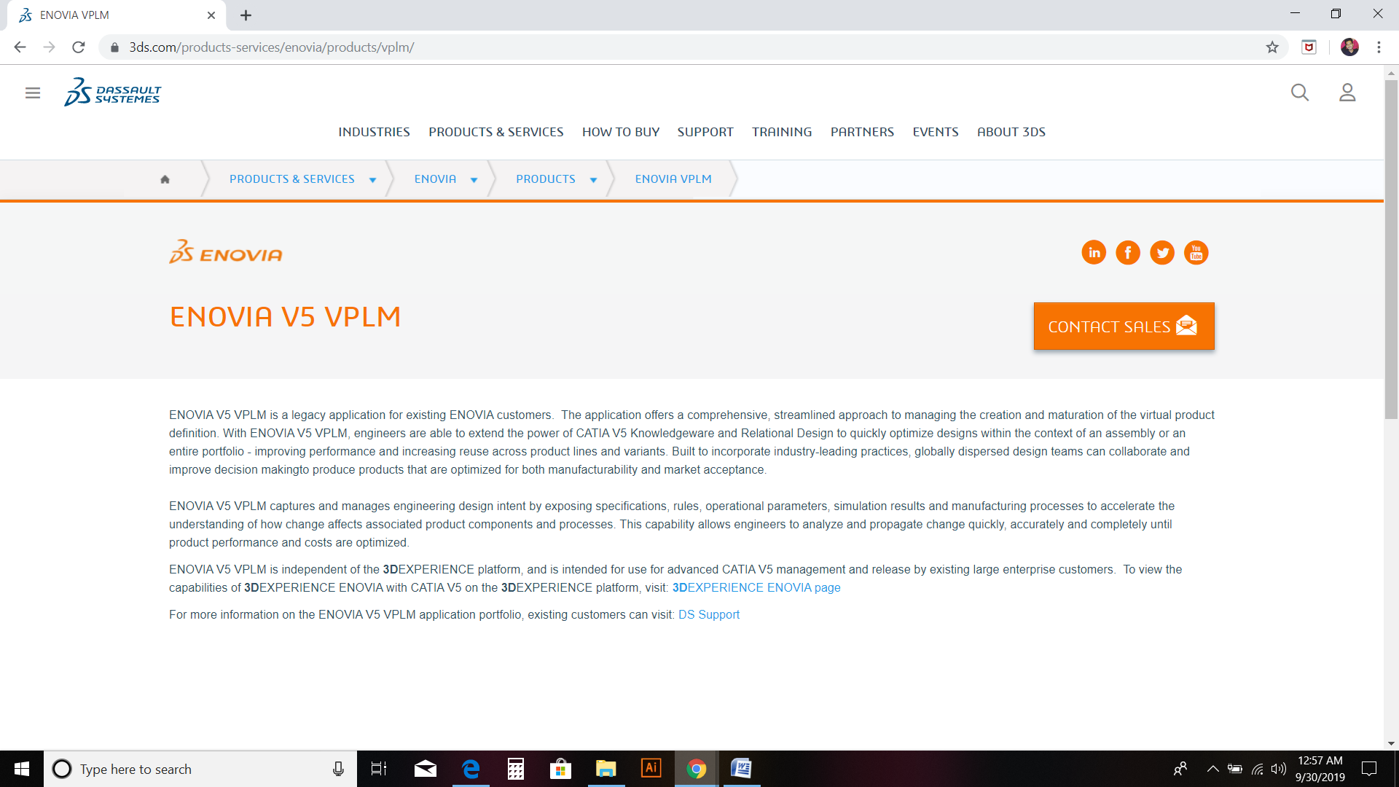

1. Does the user have the freedom to exit the website instead of going through the extended dialog box?

Result: **PASS**

Reason: In the below image, if you observe, there is a home icon in the breadcrumb which leads to the homepage directly. These kinds of commands are available in the DS website. So hence, the user has the freedom of leaving the website instantaneously.

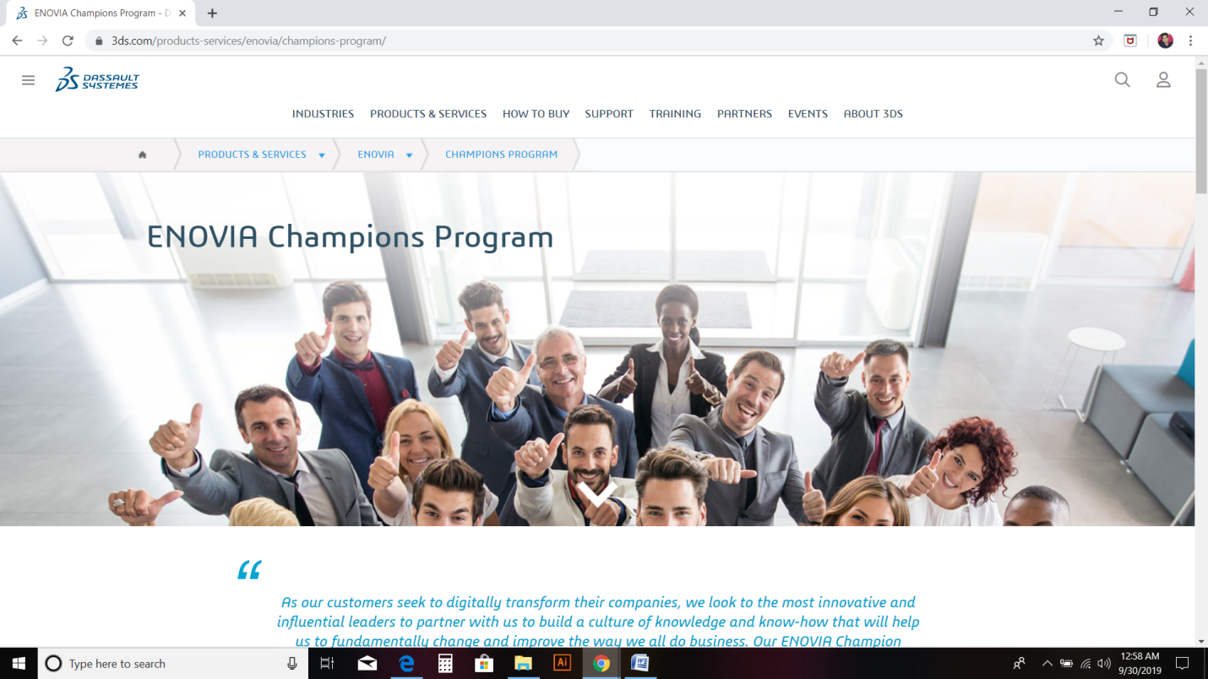

1. Is there is consistency in the website?

Result: **PASS**

Reason: As far as I have explored through the website, I did not find any inconsistency in the commands action.

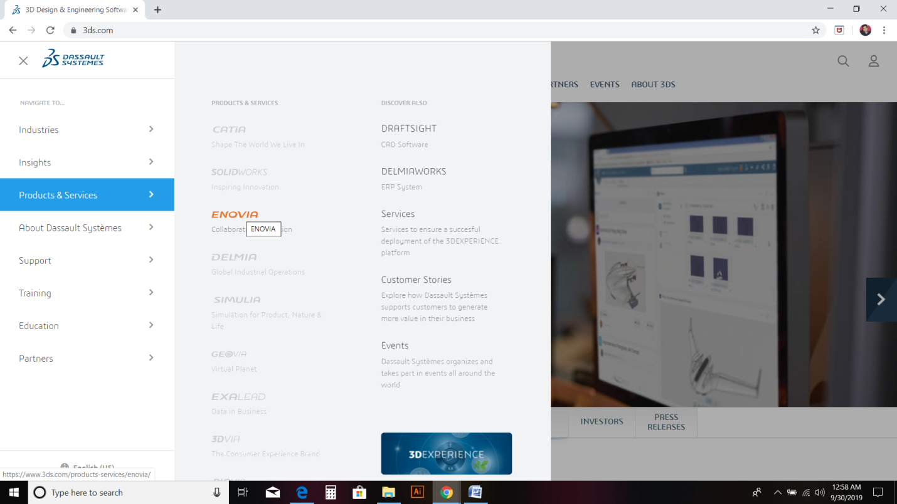

1. Are there error messages in the website? Even if there are, do they show the relevant and proper message for the user to understand easily?

Result: **PASS**

Reason: As I have gone through the website, I did not any error message as of yet. So it is often better that the website is error free.

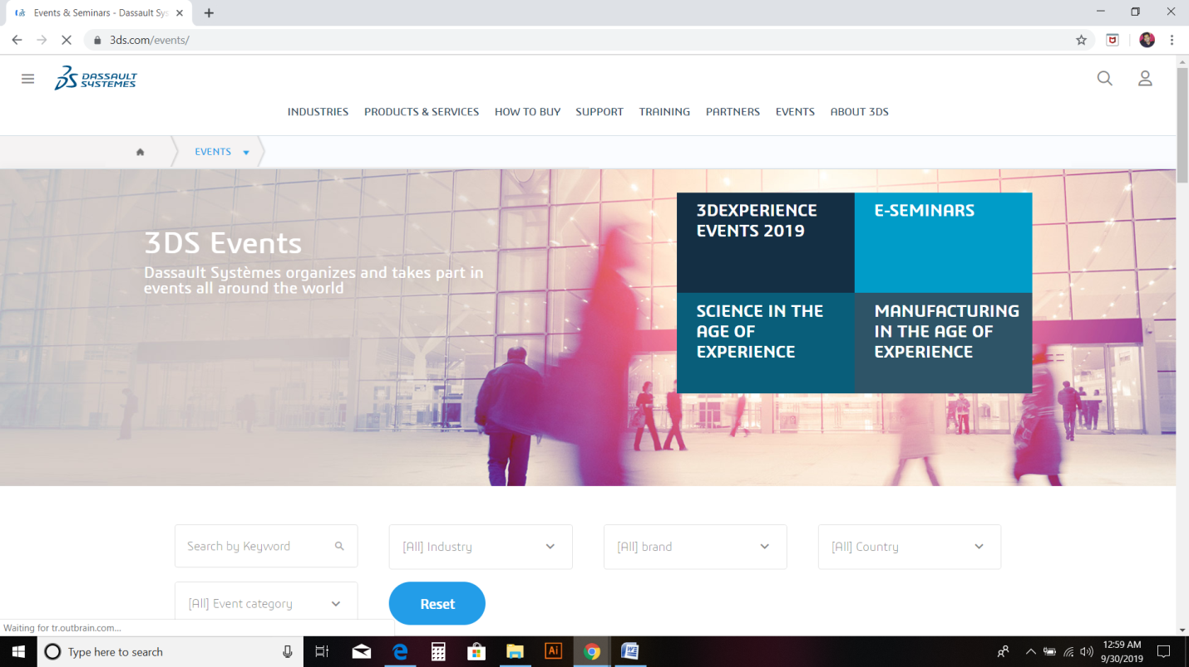

1. Is the user able to recognize the information that he is searching for?

Result: **PASS**

Reason: The description provided on the pages is allowing the user to understand and recognize the information that he is searching for.

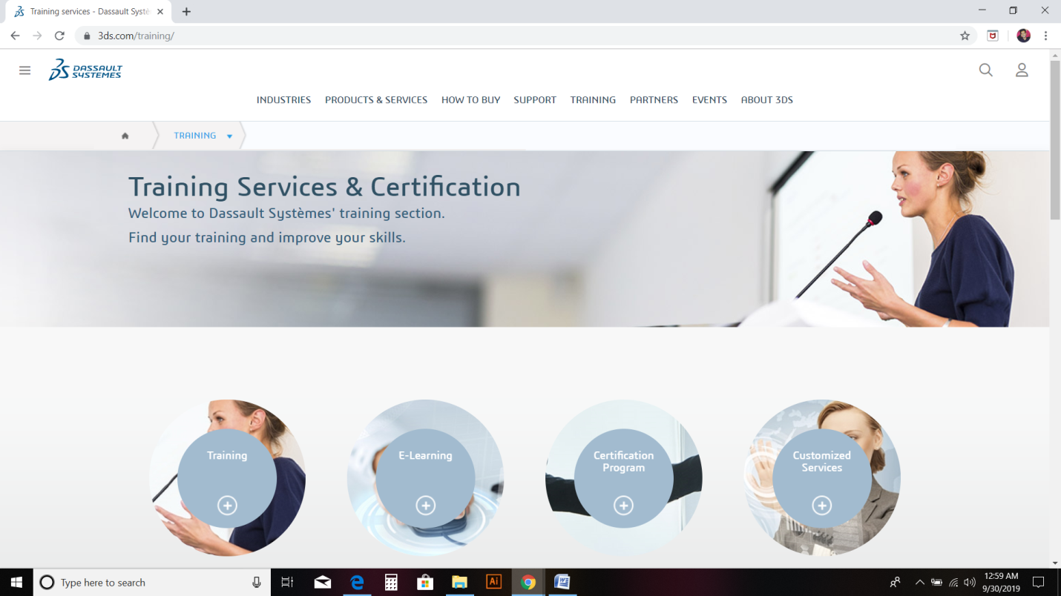

1. Is the website efficient in usage?

Result: **Pass**

Reason: The website is very efficient, and it caters the interaction to both inexperienced (novice) and experienced users.

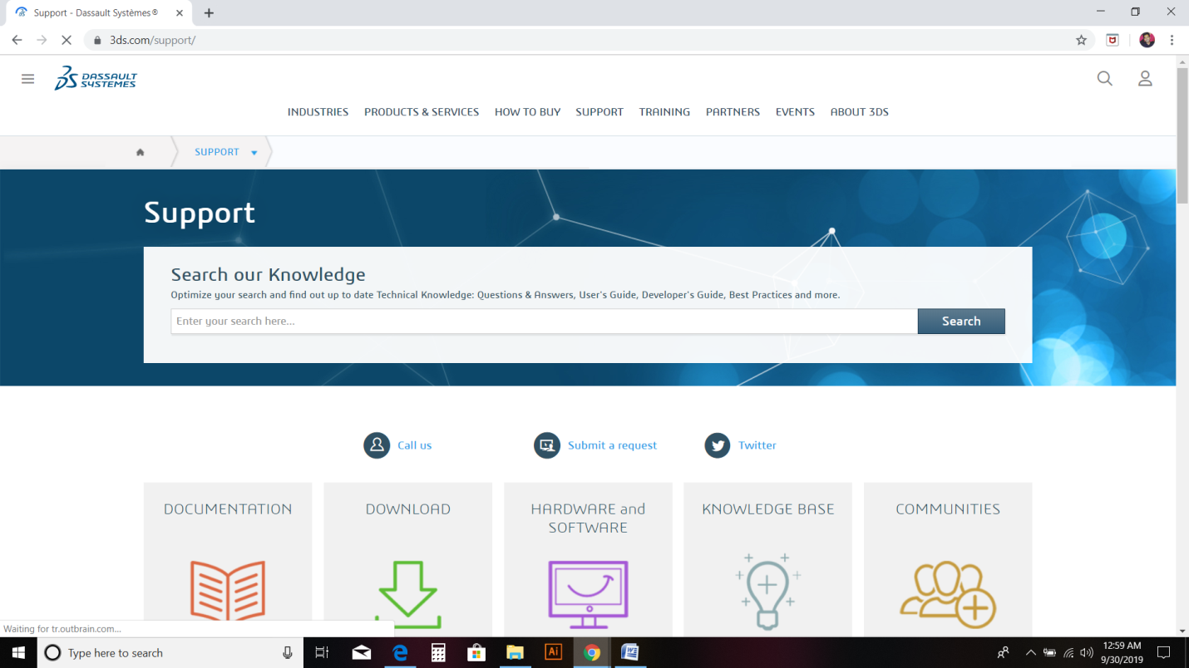

1. Does the user have the control of the personal information?

Result: **FAIL**

Reason: The user can create the profile in the website, but cannot delete the profile. Even if there is a way, it is complicated. Thus, user has no control of his personal information.

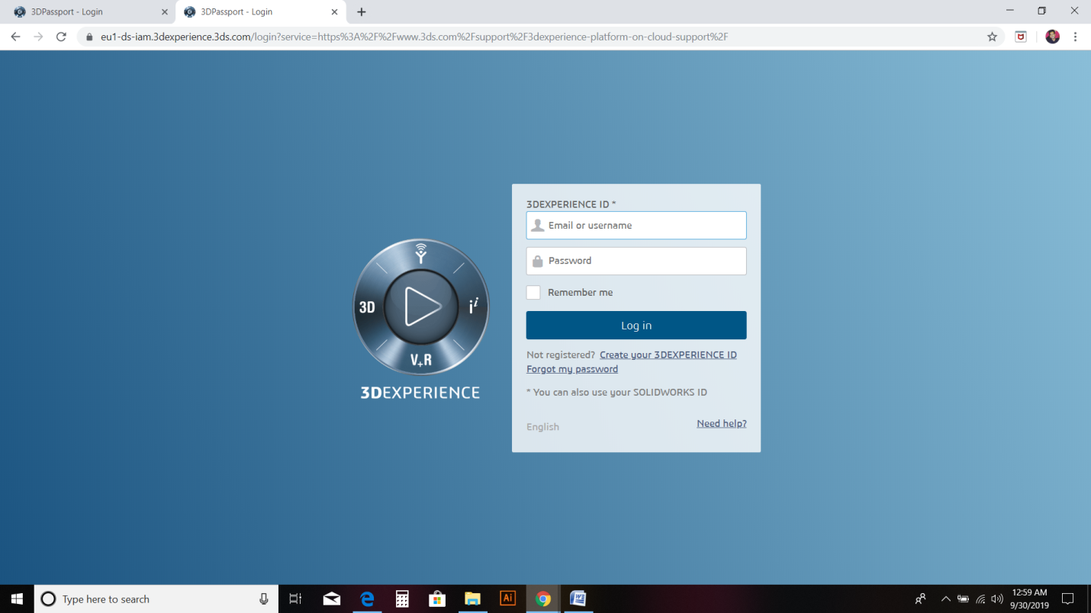

1. Is the user interface design is simple to understand?

Answer: **PASS**

Reason: The user interface design of the DS website and simple and minimalistic is design, which helps the user to understand easily.

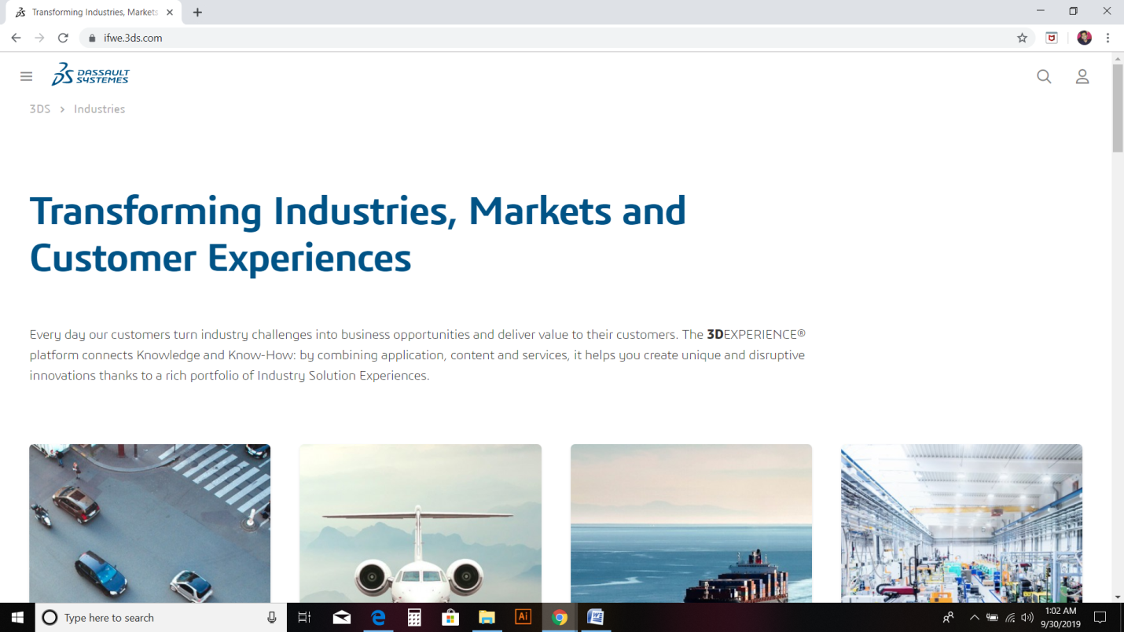

1. Are there are consistent design standards of headings?

Answer: **PASS**

Reason: The fonts and the color usage in the website are user friendly. This helps the user to access the website with watchfulness.

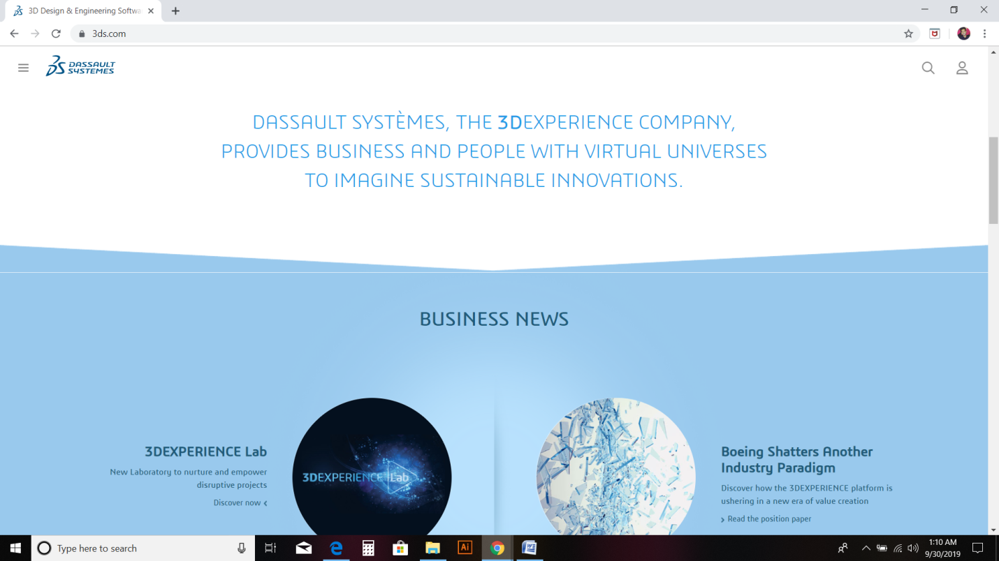

**Concluding**:

“There is always space for improvement, no matter how long you’ve been in the business “

* Oscar De La Hoya

Based on the results, there are some issues in the website, which can be rectified. According to the results, we can say that the website is efficient and user friendly, but can be improved even better for the best user interface.